

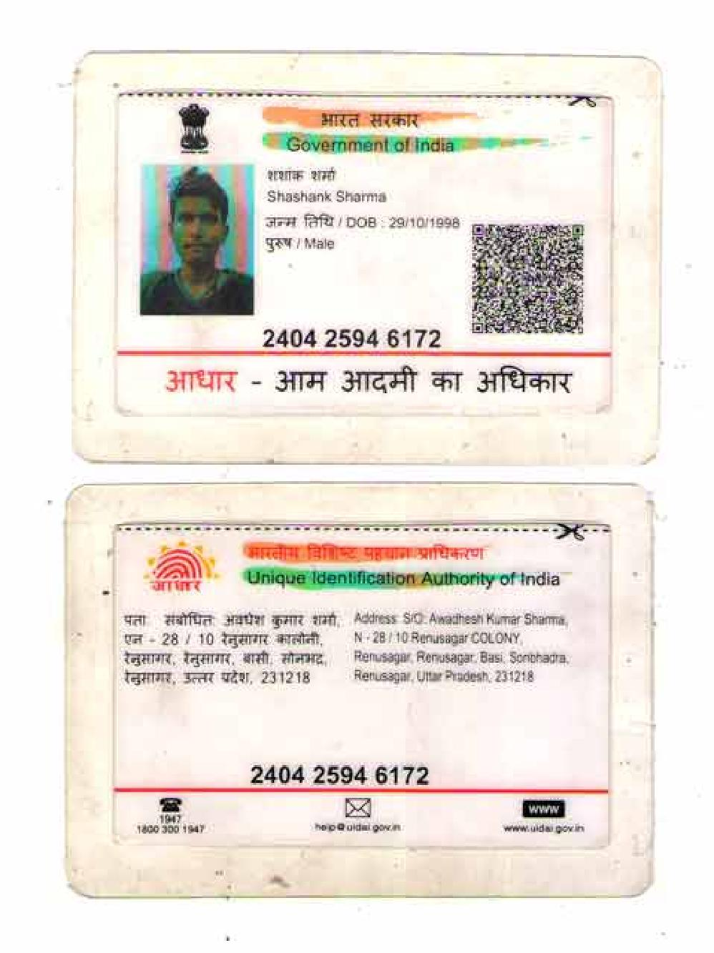

linkedin.com/in/shashank-sharma-384a871b5

Shashank Sharma

Data Engineer
+91-7800350496 @ 1029shashank@gmail.com • Bangalore • LinkedIn

EXPERIENCE

Data Engineer

Tata Consultancy Services
Institute of Engineering and Technology, Lucknow

06/2021 - Ongoing • Bangalore, IN
2017 - 2021
GPA 6.84/10

Currently working for a client which is the second largest bank in Europe in DataOps team.
- Conceptualized, designed, developed and productionized Extract,

Transform and Load pipelines from disparate data sources in Real Time or

Aditya Birla Public School

Batch Mode.
- Used technologies like Spark, SQL, python and Kafka for development of various complex real time applications.
- Developed next generation of functionalities and dashboards by analysing
2016

SKILLS
GPA 8.82/10

unused data in the catalogue and optimized resource distribution and management to increase performance of spark jobs and reduce cost.

- Automations around Monitoring and Alerting for Data Pipelines, Data Infra.

Programming

Python SQL Java Scala

Data Analyst Trainee

Brainnest

05/2020 - 06/2020 • Bremen, Germany
- Acquired data from different projects and analysed it using IBM-SPSS software.
- Executed the steps of hypothesis testing and calculated a variety of statistical tests (e.g., z score, t test).
- Interpreted the results of statistical analysis and reviewed other team
members’ interpretations of the same.
- Collaborated with team members to discuss strengths and weaknesses of various statistical tests and choose the appropriate test.
- Deep dived into the concepts of descriptive and inferential statistics.

Summer Intern

Hindalco Industries Limited
07/2019 - 08/2019 • Renusagar, IN

Data

Spark MySQL Hadoop Hive ETL Pipelines Big Data Kafka MapReduce Tableau NoSQL
Linux/Unix Data Analysis IBM-SPSS Data modelling Machine learning

Cloud

Google Cloud Azure Big Query

Database Administration Team
- Designed new databases and web pages, connected the database to web pages using visual studio.

- designed a login page for the firm deploying above learnings.
- learned about the GPS model deployed in the firm.

PROJECTS

Automating online proctoring using AI
11/2020 - 06/2021 • Lucknow, IN
AI | Python, TensorFlow, OpenCV, Dlib, NLTK, PyAudio
- Developed an automated proctoring system to detect if the test-taker is cheating using a webcam and microphone. The user is monitored on multiple vision and audio-based objectives.
- It has six vision-based functionalities: gaze tracking, mouth open or close, person counting, mobile phone detection, head pose estimation, face spoofing detection.
- It has a single audio-based functionality: matching the test taker’s words with that of the question paper and returning the common words to the proctor.

Soft skills
Problem solving collaboration Communication Leadership

CERTIFICATIONS

  - IBM - Data Engineering Essentials.
  - Data Analysis Industry Training.
  - Tableau Desktop Professional.

EXTRACURRICULAR

α Head volunteer
    - Organised the annual CS department fest "Kriti'17".

Β Team Leader
    - Team leader in summer internship at HINDALCO INDUSTRIES
LIMITED.

∞ Basketball
    - Part of the college basketball team.

